TUFF+ houses run on DC power from PV SOLAR panels.
DC electricity in homes lowers solar costs by simplifying systems and increasing efficiency, eliminating power loss from multiple conversions between solar DC and household AC power. It provides off-grid readiness by directly using the DC power from panels and batteries, making homes self-sufficient from the grid. This approach is especially cost-effective and efficient for new constructions with DC-powered appliances, reducing reliance on energy-intensive inverters.
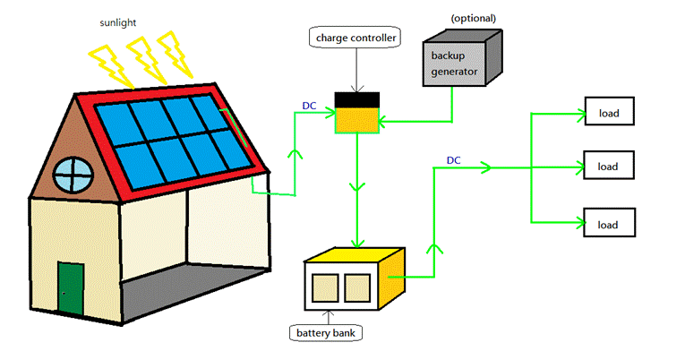

Overview and architectures
Direct-DC house (minimal AC conversion): DC from panels/battery is distributed to DC-native loads (LED lighting, DC-DC appliances, electronics via built-in DC supplies). Very high efficiency for those loads; requires designing or replacing many household devices for DC compatibility.
DC microgrid with local AC conversion: PV → MPPT charge controller → DC battery bus (typically 48 V or higher) → inverter(s) required only where AC is needed.
DC is most common in off-grid and hybrid systems; reduces inverter runtime, improving efficiency and reliability.
Full AC house with PV/inverter: PV → inverter → house AC panel; conventional, easiest to integrate with existing appliances and grid, but incurs conversion losses.

Key components for a DC-based house
PV array with MPPT charge controllers sized to house load and location.
Battery bank designed for DC-bus voltage (24 V, 48 V, 120 V DC, or higher). Lithium batteries recommended for energy density and cycle life.
DC distribution bus and breaker panel: DC-rated wires, connectors, fuses, breakers, and isolation switches. DC circuit protection must be rated for continuous DC arcs.
DC-DC converters to provide standard voltages for devices (5 V, 12 V, 24 V, 48 V, 54 V, 120 V DC) as needed.
Inverter(s) only if AC appliances or grid export/import are required.
Monitoring, grounding, surge protection, and safety devices designed for DC systems.
DC-native appliances or retrofits: DC LED lighting, air-source heat pumps with DC compressors, DC refrigerators, DC HVAC controllers, DC EV chargers (or AC charger with inverter).

Voltage choices and implications
Low-voltage DC (12 V, 24 V): easy for small loads, high currents for household power — large copper conductors, higher losses; better for lighting, small appliances.
Medium-voltage DC (48–60 V): common compromise — safer (below extra-low/high risk thresholds varies by jurisdiction), lower current, common battery standard.
High-voltage DC (120–400 V+): reduced currents and conductor size, better for whole-house distribution; requires stricter insulation, safety, and DC-rated equipment; 120–380 VDC bus is used in advanced microgrids and telecom/industry.

Safety and code
DC behaves differently from AC: arcs are harder to quench, polarity needs careful management, and equipment must be DC-rated.
Electrical codes: NEC (US) and national/local codes regulate installation, battery storage, inverter interconnection, and DC bus implementations. Some jurisdictions require licensed electricians and inspections.
Isolation and emergency disconnects are mandatory. Firefighting and first-responder considerations must be addressed.

Appliance compatibility and retrofitting
Electronics and LED lighting often accept DC internally; many devices such as phones and computers already use DC internally after AC-DC conversion.
Resistive loads (electric water heaters, ovens) work on DC but require DC-rated controls.
Motors and compressors: most AC motors need inverters; modern HVAC and refrigeration increasingly use brushless DC motors that can run efficiently on DC via appropriate drives.
Cooking, clothes dryers, and most major appliances are now available in DC - exceptions are more challenging to convert; often easier to keep them AC and use a small inverter or hybrid approach where necessary.

Efficiency, cost, and practicality

RUNNING COSTS are low and can be ZERO!
If used in a tropical or sunny climate, the electricity generated and stored in a TUFF+ house battery block can be sufficient to run lights, appliances and air-conditioning all day and night.
TUFF+ converts the excess heat into cooling and running the house.
NOTE Efficiency: Every AC/DC or DC/AC conversion adds loss. Eliminating unnecessary inverters and rectifiers improves system efficiency. TUFF+ takes direct SOLAR DC electrical supply and using it without inefficient conversion.
Cost and availability: DC-native household appliances are now available via the RV supply market. Battery and DC distribution costs vs. savings from reduced inverter hours should be evaluated.
Maintenance: DC systems require technicians familiar with DC safety and battery care.

Typical use cases
Off-grid homes: DC battery bus with inverter backup is common to minimize inverter runtime and maximize efficiency.
Net-zero or grid-tied homes: PV with inverter, battery backup, and selective DC distribution for critical loads (lighting, comms, pumps).
Tiny homes, RVs, boats: often run primarily on DC (12–48 V) because loads are smaller and designed for DC.
Remote telecom/industrial sites: use high-voltage DC buses routinely for efficiency.
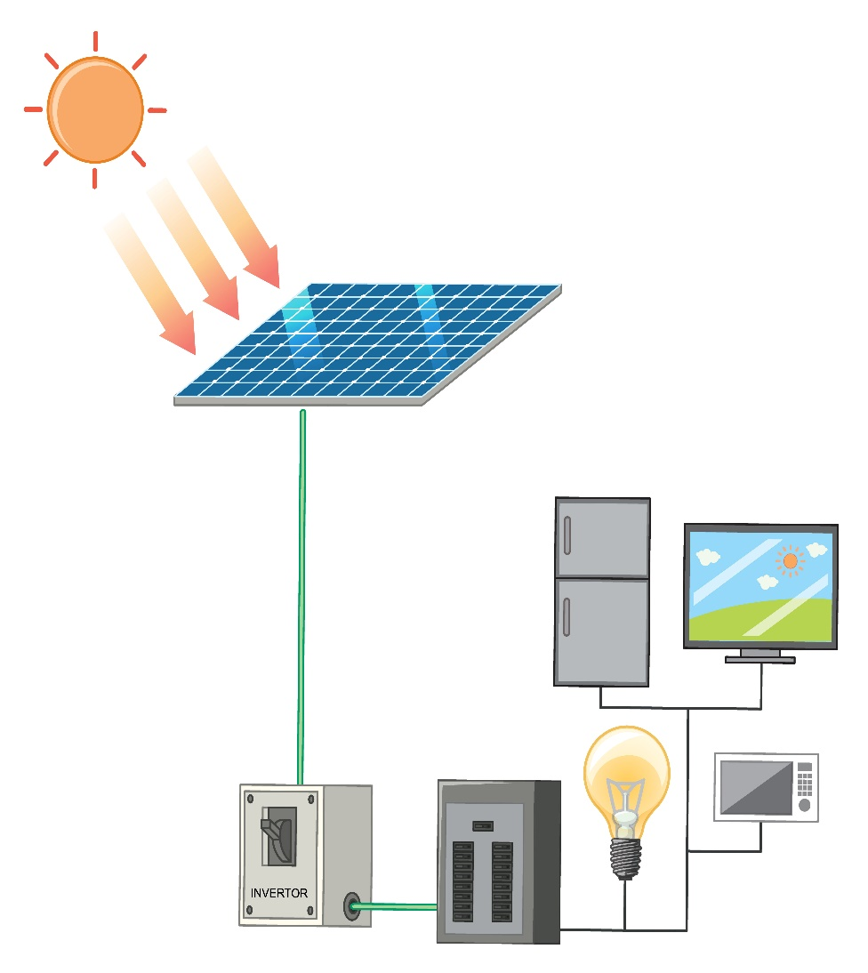

Practical implementation steps (Technical)
Audit loads: list appliances, power ratings, duty cycles; separate DC-friendly vs AC-only loads.
Choose DC-bus voltage that minimizes current while remaining safe and supported by equipment (48 V is a common starting point).
Size PV array and battery capacity to meet energy and autonomy goals.
Design DC distribution with DC-rated breakers, wiring, and surge protection.
Select DC-native appliances where cost-effective; use high-efficiency inverters only for unavoidable AC loads.
Install per local code with licensed professionals; include monitoring and maintenance plan.

Conclusion
Running a house largely on SOLAR PV-generated DC is technically supportable and more efficient for DC-native loads, by selecting appropriate DC voltages, using DC-rated protection, and using DC built appliances.
A practical alternative for those who want standard 110V or 240V power is a DC battery bus with selective DC distribution plus an inverter for remaining AC loads;
Full DC-native houses are best in new-build scenarios where appliance choices and safety are planned from the start. That is what TUFF+ Houses supply.

DC LIGHTING SUPPLY OPTIONS
https://www.alibaba.com/product-detail/TUYA-High-Quality-Smart-Downlight-RGB_1600659287509.html
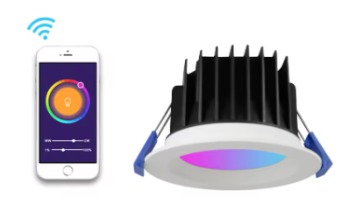
Requirement: a Shanghai based manufacturer of LED lighting which supplies product in 12 -48DC voltage.
Specifically looking for smart home option able to be switched from phone or other remote
In Shanghai Free Trade zone:
https://yidiled.en.alibaba.com/company_profile.html
They have 110v AC LED but https://www.alibaba.com/product-detail/Stocked-Led-Flat-Panel-Light-120_62376876678.html
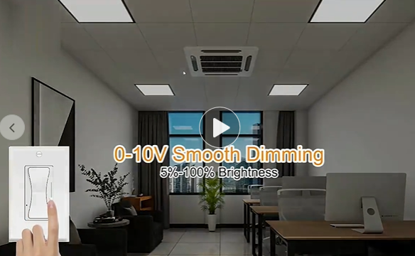
Also pot lights that dim and change color thru remote/phone

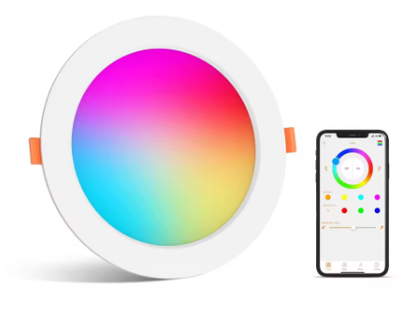
4" 6" LED Recessed Round RGB Color Changing Panel Light 110-130V WiFI Smart Downlight with Junction Box
What the Manufacturer Would Need to Do to provide DC LED lighting:
- Instead of swapping the LED, a manufacturer would essentially need to design and build a new product. This would involve:
- Replacing the Power Supply: (this will save money in manufacture) replacing it with a 12V DC input.
- Rewiring the Fixture:
- The fixture's internal wiring would be reconfigured to accept the 12V DC input.
- The LEDs themselves would need to be compatible with the 12V DC low-voltage power supply.

For lighting implementation, have a look at KINETIC SWITCHING:
from https://vivilite.en.alibaba.com/zh_CN/index.html?spm=a2700.details.0.0.414163c7GHqkLY&from=detail&productId=1600843206031
​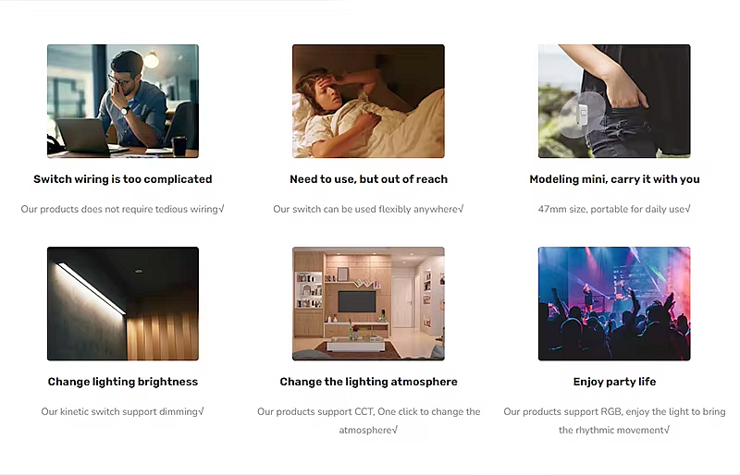
This is revolutionary, and is low cost alternative to switch wiring.
​
My belizean electrical engineer, Elvir, has studied in the UK with major lighting firms about smart home lighting, and wants to work with us.
He can also advise on best methods to implement what is in the attached doc about 12-24 or 48v DC because he has been trained to do this.
POP MARKETING
- This is very powerful story to sell our homes. The cost of a basic SOLAR pack in a small home with airconditioner included (as shown) along with the impressive glass that changes to opaque that Mr Chen demonstrated on his tree house, such as those provided via https://ytrushui.en.alibaba.com/zh_CN/index.html?spm=a2700.details.0.0.fb182c43JGL0mv&from=detail&productId=1600074965381
​(this is a film incidentally, not an expensive glass - and it significantly reduces the heat coming in from sunlight)
​
This is the MARKETING POP that will get TUFF+ into the global awareness we are looking for.
The most impressive aspect is that the reduction in cost of electrician time in having to wire switches will (IMO) be more than the cost of all of these features!!!
I need someone local (maybe from TH or Porshseal?) to talk to VIVI https://www.alibaba.com/product-detail/Wifi-Kinectic-Lights-Wall-35a-Dry_1600844502466.html
who are based in your free trade zone in Shanghai. I think the importance of that (and the location) would suggest you personally find out more (I can accompany you via video call for tech support if you wish)

DC lighting with smart phone/remote connection https://www.alibaba.com/product-detail/TUYA-High-Quality-Smart-Downlight-RGB_1600659287509.html from https://sklighting.en.alibaba.com/index.html?spm=a2700.details.0.0.70f67faa6JjaUQ&from=detail&productId=1600659287509
https://gv.videocdn.alibaba.com/7c569251818fbca4/OCDJRjT3wf7M7wOFHCH/KjiZVUFnfhZt2y0PKkc_318073101068_mp4_264_hd.mp4
This is a LED splitter with remote control for 6 lights
From https://vivilite.en.alibaba.com/zh_CN/feeds.html

SOLAR AIR CONDITIONING PACK AS THE BASIS FOR DC HOUSE SUPPLY:
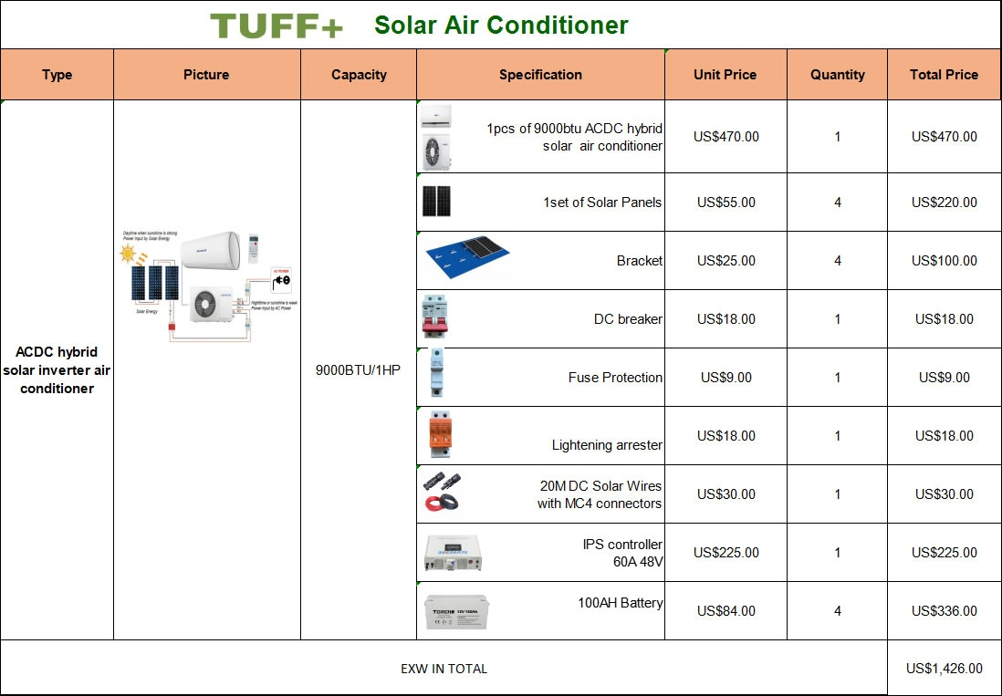
This solar kit with AC is very affordable – Zain says he can sell these in Belize like hotcakes! Benny’s will also be interested. I have said they are $2000USD EXW but these two are less than that.
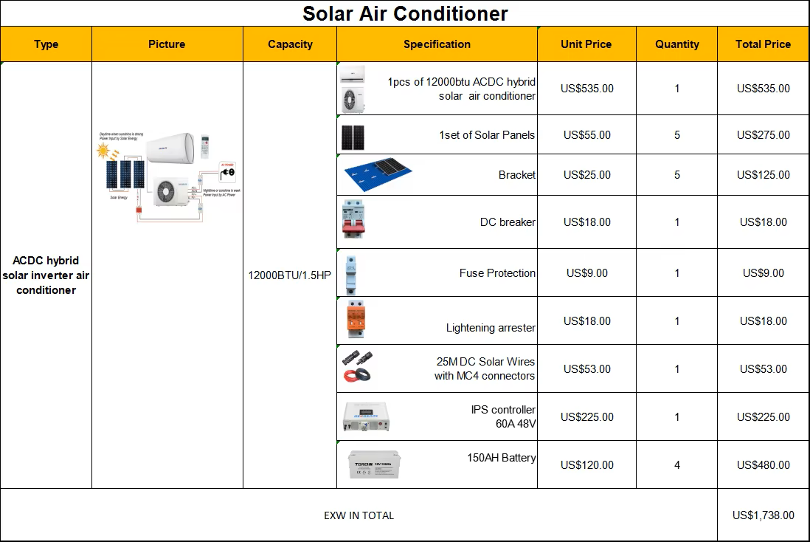
These are both from Yangzhou Dongtai Solar Energy Co., Ltd. is a professional manufacturer of solar battery and household solar system etc with more than 25 years experience https://www.torchnenergy.com/about-us/
However we need to get approval in Belize for solar installations – so a partnership is sensible with a local business. Also it would ease the time to get our demo house operating in Belize, and generate profit along the way.

WINDOW ELECTRONIC CURTAIN FILM
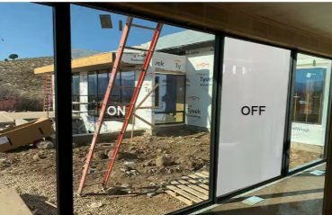
Product details
https://www.alibaba.com/product-detail/Hot-Sale-Electronic-PDLC-Smart-Glass_1601486775307.html
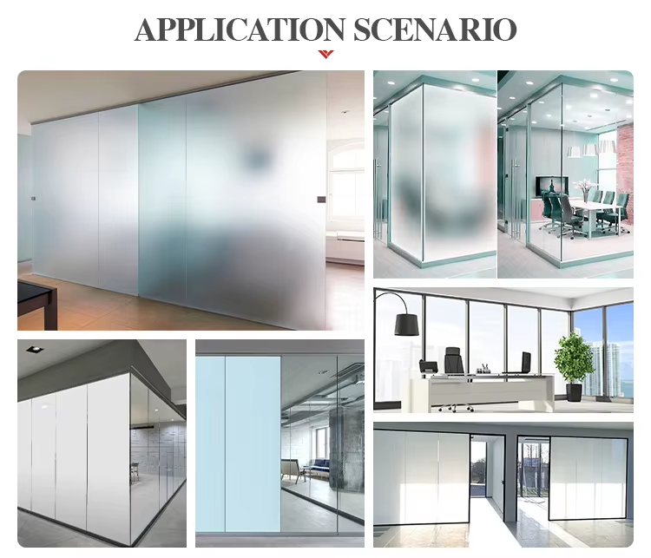
Factory video
https://gv.videocdn.alibaba.com/4f4e1c368ac918af/dd790030f1debb5c/20240305_a3c2f917f50fd398_452090314142_mp4_264_hd_unlimit_taobao.mp4
Effect Video:
https://gv.videocdn.alibaba.com/a9b5b21ee64d2b47/bKLbO6M7EeevJ3euBqy/qFTqpFgkqv8uJi9yjdq_234905582812_sd_hq.mp4
Hot selling electronic PDLC smart glass color changing atomized glass privacy dimming glass office hotel partition door glass
Product Name Electric switchable glass
Product Description 65v high transparency
switchable PDLC film
Operating Model power ups transparent
Power outage opaque
Optical performance Available colors milky Dark gray
Haze (on) 4-5% 4-5%
Haze (Closed) > 90% >90%
Perspective About 145 degrees
Light transmittance (open) 90% 32%
Light transmittance (off) 4% 4%
UV blocking > 99%
Infrared block On Model>17% Off Model >80%
size maximum Self-adhesive film roll size: 1*50M, 1.2*50M, 1.5*50M, 1.8*50M (standard)
Non-adhesive film roll size: 1*50M, 1.2*50M, 1.5*50M, 1.8*50M, 2.0*50M (standard)
thickness 0.4 mm
Electrical performance Operating voltage AC65 ± 5V
Power consumption About 3.7W/SQM
Frequency 50-60 Hz
Operating temperature -20℃--70℃
Switching time Less than 1 second (off → on: about 200 milliseconds on → off: about 600 milliseconds)
Life Time More than 100,000 hours (20 years)
Other Features Dimmer function Yes
projection screen Yes
Warranty period Two years
Hot selling electronic PDLC smart glass color changing atomized glass privacy dimming glass office hotel partition door glass
Hot selling electronic PDLC smart glass color changing atomized glass privacy dimming glass office hotel partition door glassHot selling electronic PDLC smart glass color changing atomized glass privacy dimming glass office hotel partition door glassHot selling electronic PDLC smart glass color changing atomized glass privacy dimming glass office hotel partition door glass
US$40-80 – is less than the price of physical curtains…
