TESTS REQUESTED

1 AXIAL Load testing for standard 600x3000x108 MgO/PU SIP
We are looking to exceed the required distributed loading of 1 tonnes per linear meter for the tropical (no snow) market.
Measure each loading by adding 100KG amounts as Axial (The pressure pressing down onto a column from the top) distributed loading, keeping track of side distortion.
If you have professional SIP load testing equipment that is better, but not necessary.
AXIAL TESTING RACK
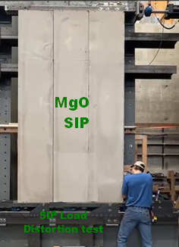

2 TRANSVERSE WALL WIND Load testing for standard 600x3000x108 MgO/PU SIP
  - TUFF+ house specifications include Category 3+ hurricane testing
  - This test can be done at a panel testing facility or by applying vacuum (negative wind) pressure to a SIP panel
TEST: Ensure that the pressure from lateral wind load on 4” (100mm) thick SIP external walls will exceed planned lateral wind pressures (Best Envirohomes is the Belizean tropical house R&D center for TUFFplus.Global )
Please view links to see details
108mm SIP test 3 tonnes of load
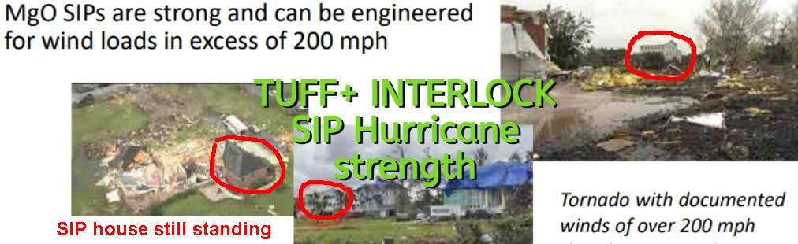

3 TRANSVERSE LOAD TABLE for TUFF+ SIP ROOFING SECTIONS

I have been unable to find any Design load table for MgO/PU SIPS
This is one for OSB/EPS which we know is an inferior product.
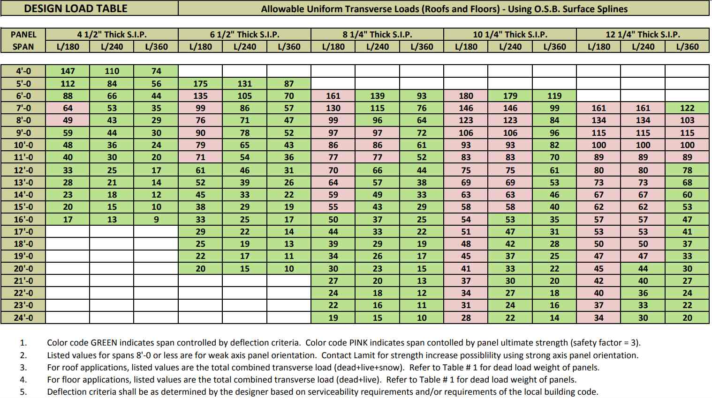
By doing this testing – which applies to both roofing and floors – and publishing the design load table OCM will open new opportunities immediately, showing the expanded beam load equivalent for MgO/PU SIP
The same table should also be made for MgO/EPS

TEST METHOD:
  - A transverse load test for a Structural Insulated Panel (SIP) involves applying a load perpendicular to the panel's face to assess its strength and stiffness.
  - Transverse Strength: The maximum load the panel can withstand before failure.
  - Bending Stiffness: The panel's resistance to bending deformation under load.
  - Deflection: The amount of bending or deformation that occurs under load. See Deflection levels, L/360 for flooring, L/180 for roofing.

  - Current SIP transverse load figures are based on OSB/EPS SIPs.
108mm thick SIP TEST: Obtain at least two 3x0.6x0.1 meter SIP panels, and 2 TUFF+ R-splines to at least 4.5m length. NOTE that a TUFF+ R-Spline is 100x80 and is very strong – allowing SIPs to span greater lengths than ever before. You can test in the interim by putting a 100x80mm steel I-beam as a reasonable substitute.
Create a SIP transverse test unit for roofing to ensure L/180: Connect the two SIPS using a mini-SIP spline between lengths, and the R-splines to bring the total length of the roofing or flooring example to 6 meters.
Take the SIP test unit to be tested for ASTM E72 transverse testing (Standard Test Methods for Conducting Strength Test of Panels for Building Construction)
OR Place the SIP test unit onto a beam load test and apply pressure to the intended load at the central (weakest) point mid beam at different beam lengths (starting with a 3m length and then bringing the free span length to wider increments and testing again.
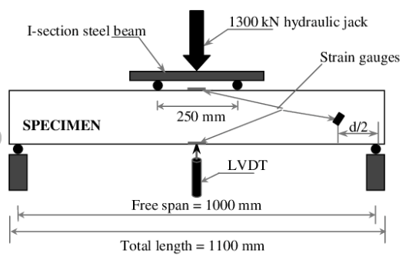
  - This test can be simplified in the case of roofing to the following simple test sequence
  - 1 place the end load points (e.g. a steel beam) on a level solid surface, and placing the SIP test unit onto the end load points. Start with a single SIP length of 3m
  - 2 Set a marker for deviation at the LVDT midpoint.
  - 3 Determine the acceptable static roofing load and placing that load (e.g. 100kg) on the LVDT and measuring the deviation in mm
  - 4 to test dynamic load, take off the static load and replace it will a person who jumps on the LVDT while measuring the deviation in mm
  - 5 once acceptable rain and maintenance loads (eg a person walking on the roof) have been tested for L/180, L/240, L/360, and L/480 deviations (in that order) you will have a good idea of the transverse load capability of the SIP at that length.
  - NOTE that if you don’t want to break the SIP test unit, do not increase the LVDT load to a point beyond which the deviation is greater than 25mm at the LVDT
Once test is completed for 108mm standard TUFF+ SIP, do the same test for 200 and 300mm SIP.
I also suggest varying the MgO thickness as per engineering requirements of an I-beam.
Structural Insulated Panels (SIPs) function similarly to I-beams in their structural behavior. The MgO facings act like the flanges of an I-beam, resisting bending forces, while the rigid foam core acts as the web, resisting shear forces. This design allows SIPs to handle compressive and bending loads effectively, making them strong and efficient building components.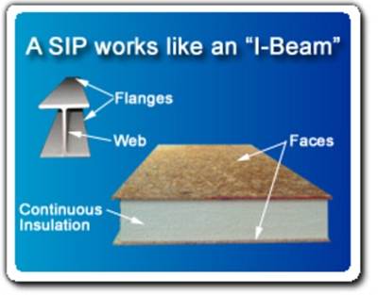
Your engineers will confirm that increasing the SIP face/side thickness will enable increased loading, both Axial and Transverse.
PUBLISHING THESE RESULTS for different MgO side thickness ON YOUR WEBSITE WILL ATTRACT NEW CUSTOMERS.
SPECIFIC GROUND FLOOR SIPs, using FRP/EPS/MgO top will also open new markets!!!

FINALLY UPPER FLOOR LOAD TESTING should be done to L/360 deflection limit

In compliance with the SIPA ICC-NTA code listing report, a 6-1/2-inch (150mm) thick SIP using a standard Mini-SIP can be used to span 8 feet carrying 56 psf (273.416 KG/m2) for upper floors at a deflection limit of L/360 which is adequate for most residential floor applications. (Center Deflection will be less than ¼” or 6mm for that load)

4 AXIAL load testing for 6mx300mmHx120mmW SIP (10mm FRP pultruded glass sides /and 100mm EPS foam)

Create a sample SIP with FRP Sides, insert and affix the top spline, and do a compression test of the sample on level tamped soil/concrete/rock till distortion or breaking occurs. Measure each loading by adding 100KG amounts as Axial (The pressure pressing down onto a column from the top) distributed loading, keeping track of side distortion.
We are looking to exceed the required loading of 2 tonnes per linear meter.

5 MgO Flame thrower test


